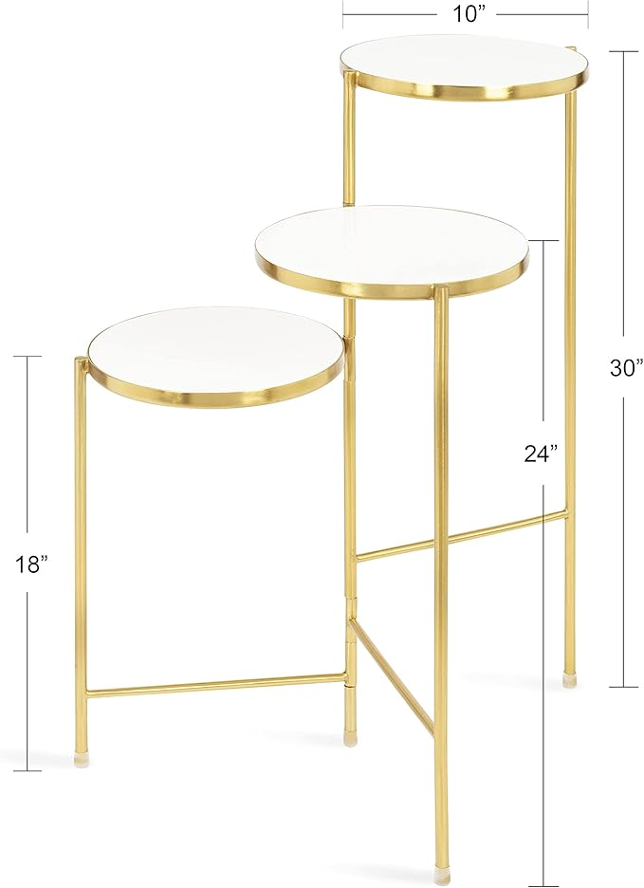

$103

Kate and Laurel Fields Modern Tri Level Plant Stand, White and Gold, 10 x 10 x 30, Decorative Wood and Metal Multi Tiered Planter